**Fake News Detection By AI**

**Introduction**

In today’s world, the major problem the world is going thorough is misinformation spreading across the world. These

Misinformation influences the public opinions leading to riots, big issue, and somewhere affect the financial markets, elections and even health decisions.

If we try to address this issue, we should move to ai and nap for checking the information to figure out its correctness and authenticity.

**Background**

* According to the MIT study, fake news spreads 6 times faster than factual information.
* During elections, Covid-19 epidemic and stock markets a large amount of misinformation spreads.
* Traditional method of checking is too slow for this generation.

**Overview**

**Working of fake news detection system**

* Analyse the text structure (headline, content, writing style)
* Cross referencing from the reliable news sources and check authenticity.
* Detection of sentiment and bias (use of exaggerated or misleading claims)
* Usage of ML models trained on real vs fake datasets to categorize articles.

**Working Principle**

**Algorithm**

1.Submission of news article/link by user

2. NLP pre-process the text as given in news (eliminates stop words, stemming and tokenization)

3.Now ML model classifies which is fake or real news on historical data and pre- learned model.

4. Then system assure by giving a confidence score and suggest credible sources to gain correct information about the same topic

**Flowchart**

**Application and utility**

* Monitoring social media news: Use of AI in social media platforms in Facebook and Instagram to detect and flag fake news.
* News Agencies & Journalism: Automated fact-checking tools for the news publishers.
* 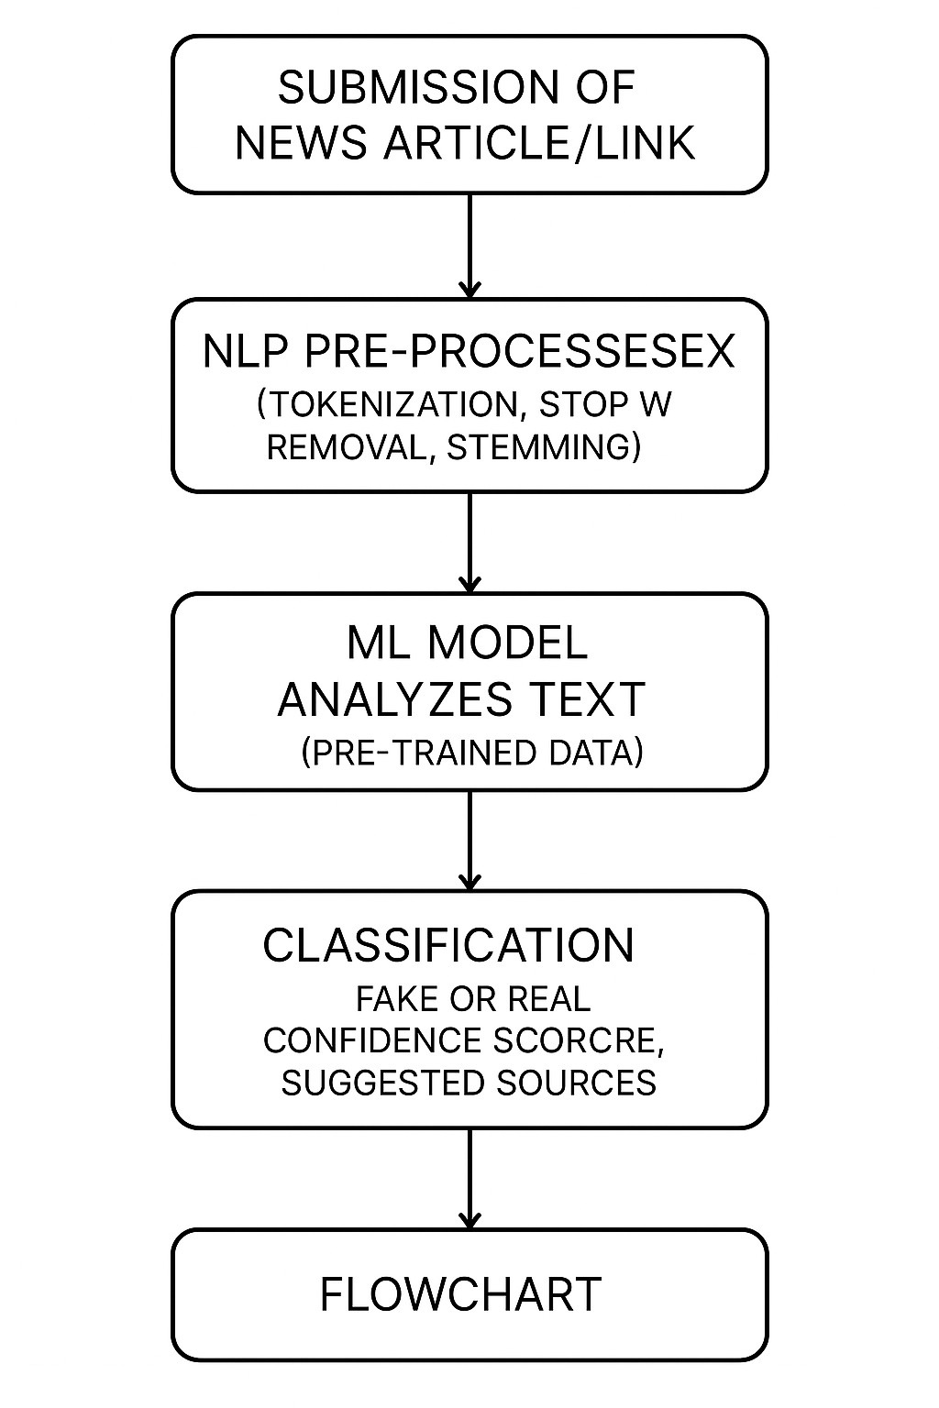Policy making and Government: Prevention of misinformation in elections and public safety.
* Public Awareness: Provide awareness to verify news believing or sharing it.

**Conclusion**

This AI model make a momentous change in today’s world as it prevents spread of misinformation, as AI can automate fast-checking based on pre-learned model, but human verification is still needed. Advancements in deep learning, and real -time checking will improve the effectiveness of AI- based fast checking.